**SQL ASSESSEMENT**

S.R.TAANUSRI

13.12.2023

**QUESTION 1:**

Querying Data by Using Joins and Subqueries

s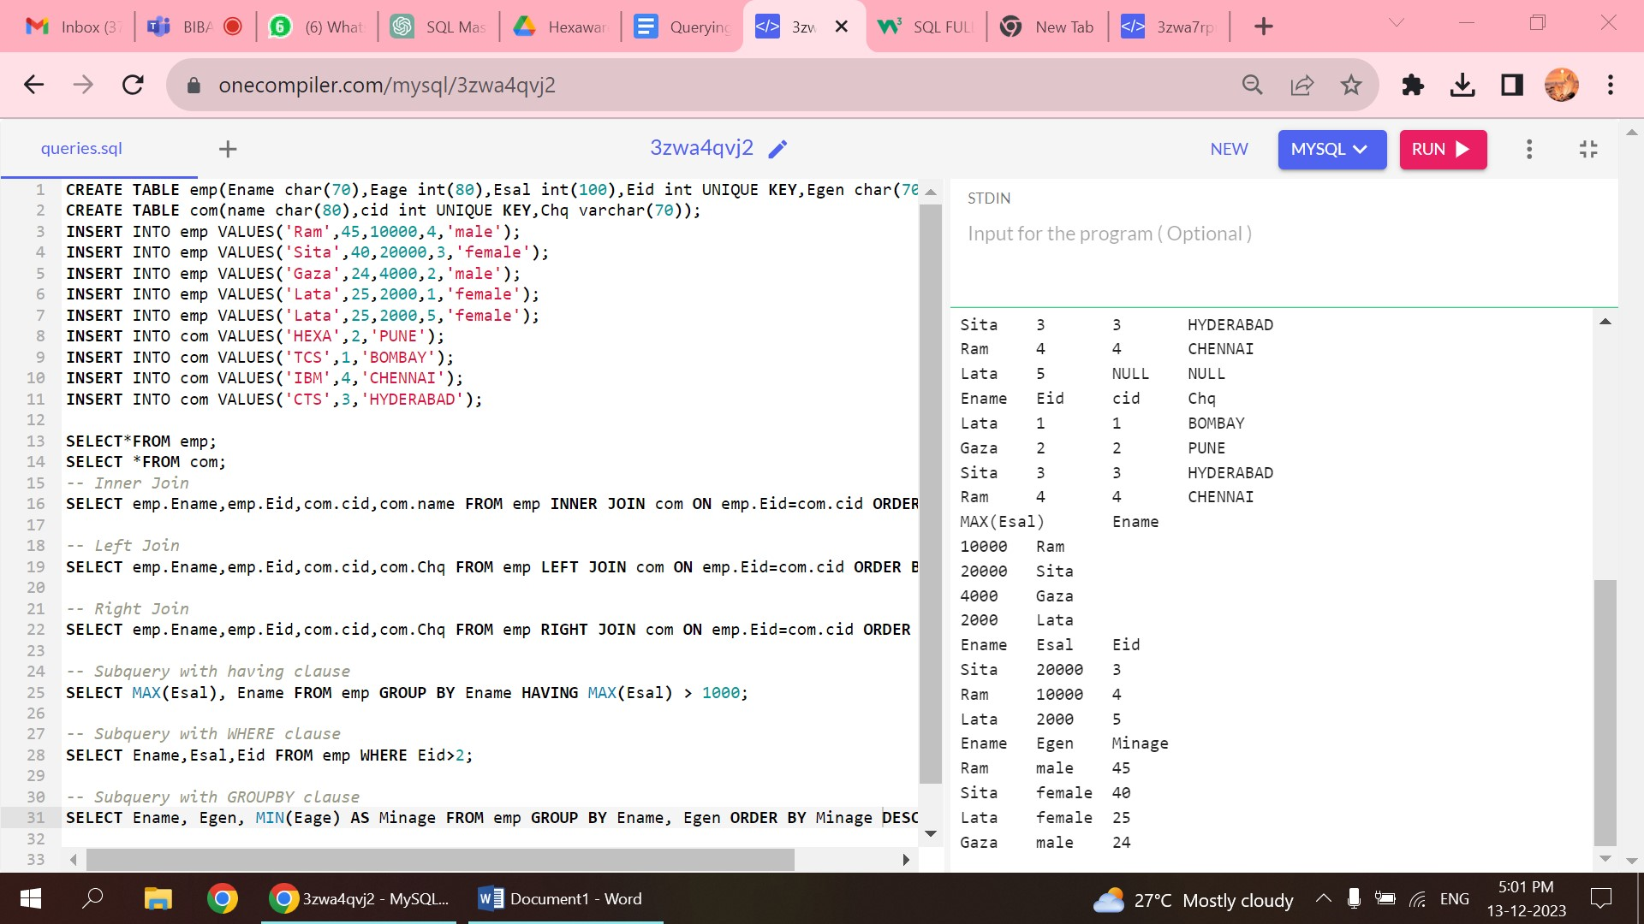

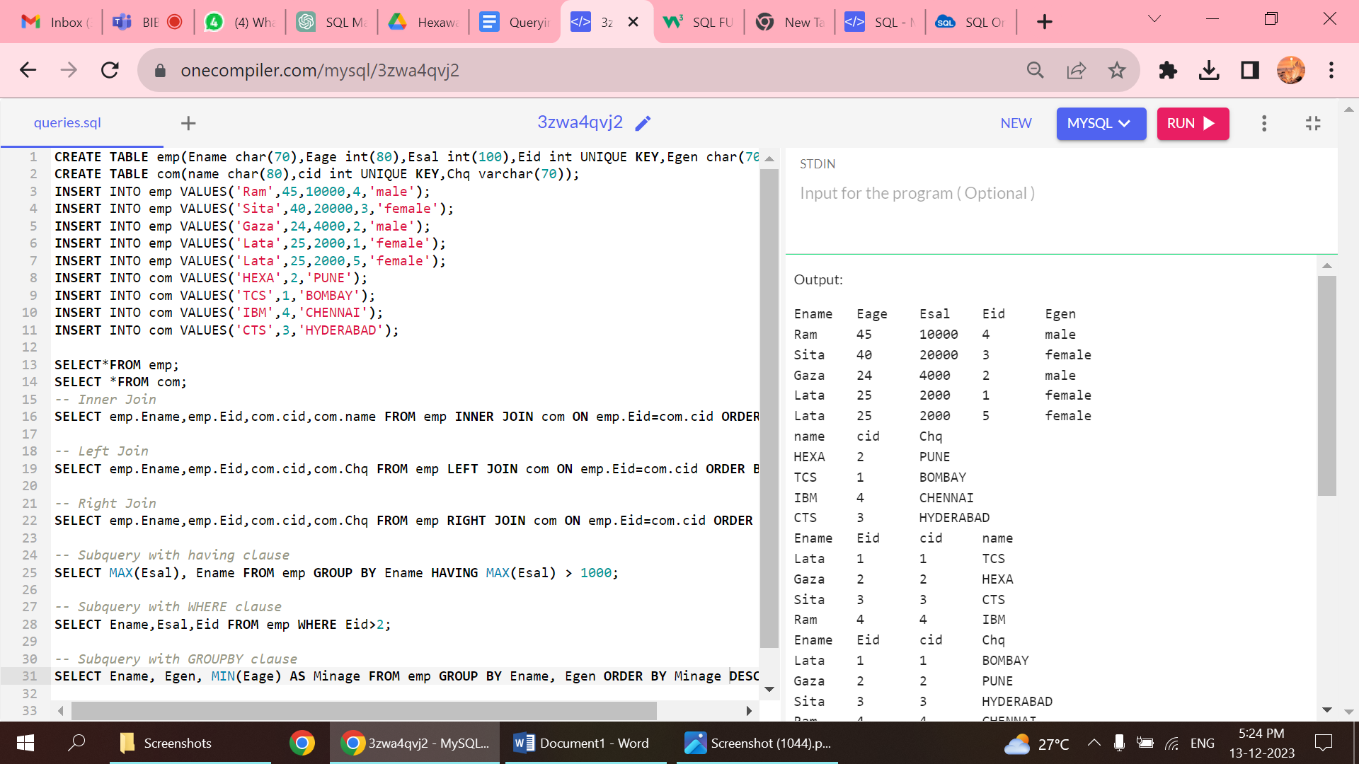

1.TABLE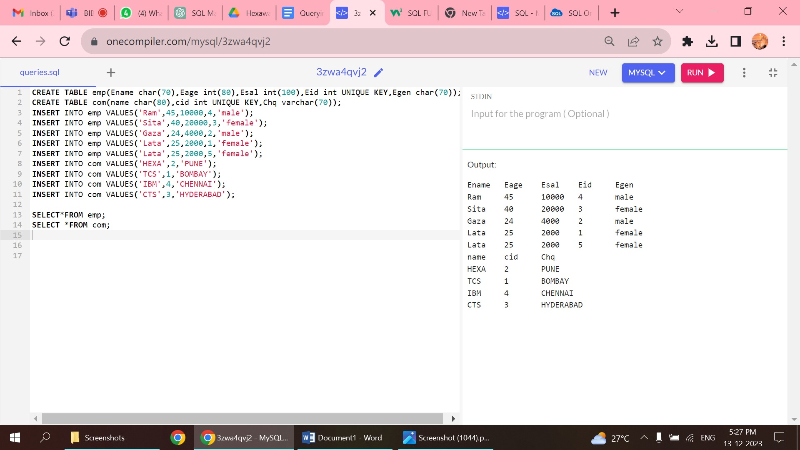

2.INNER JOIN

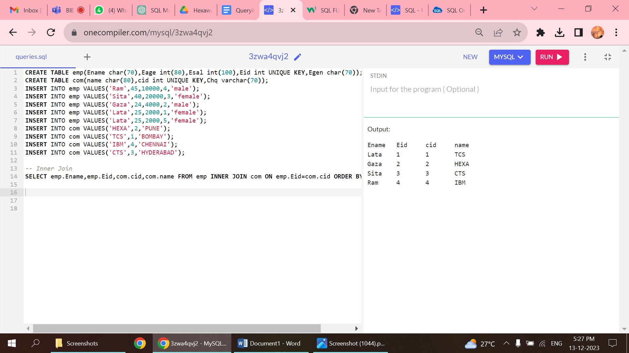

3.LEFT JOIN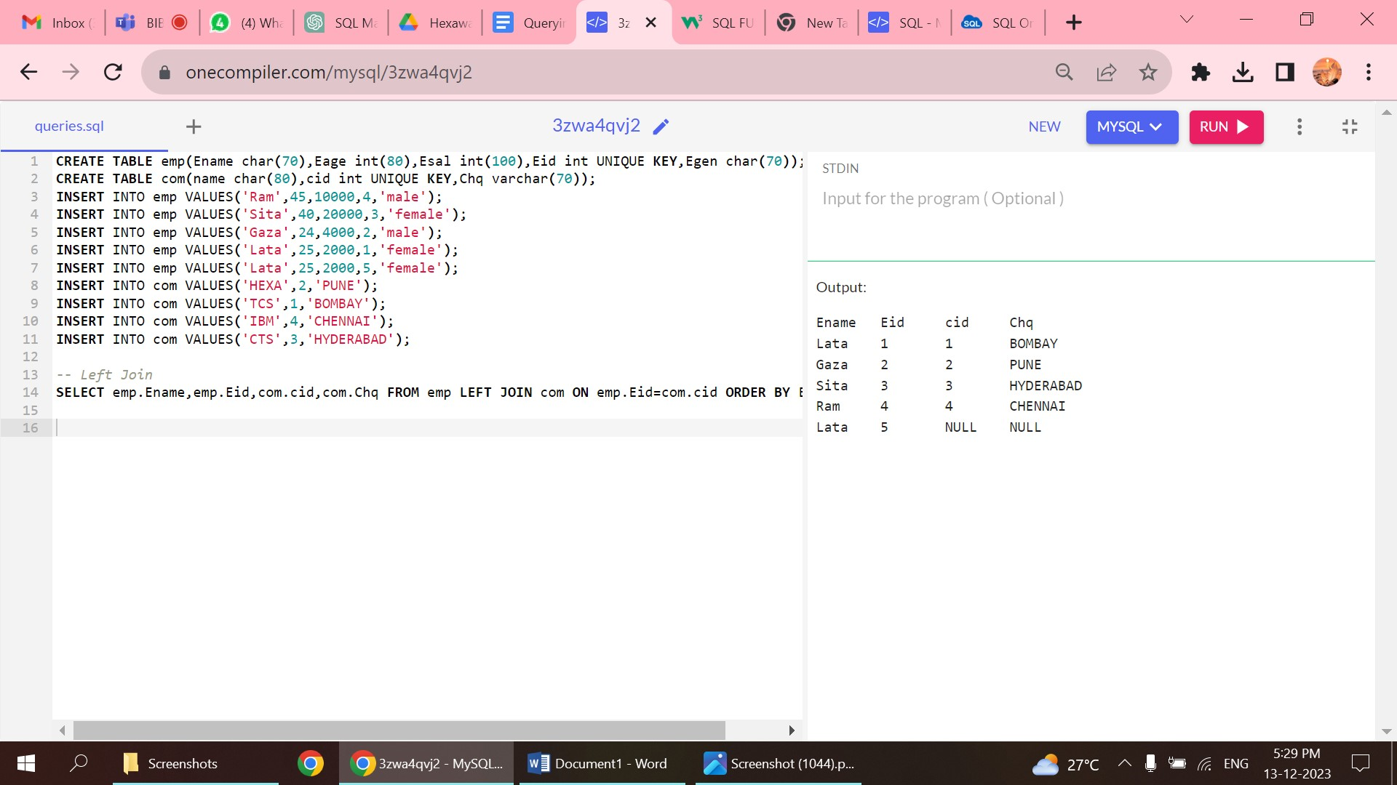

4.RIGHT JOIN

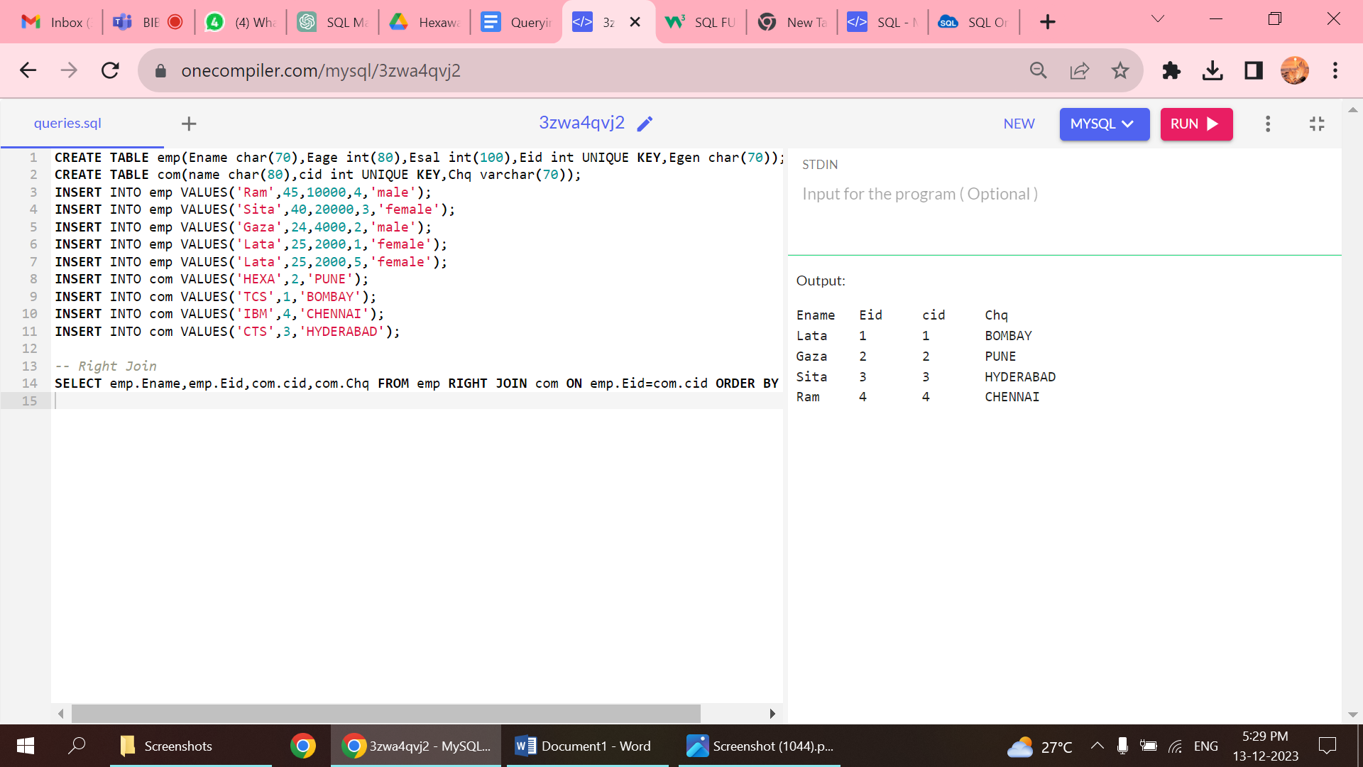

5.SUBQUERY WITH HAVING CLAUSE

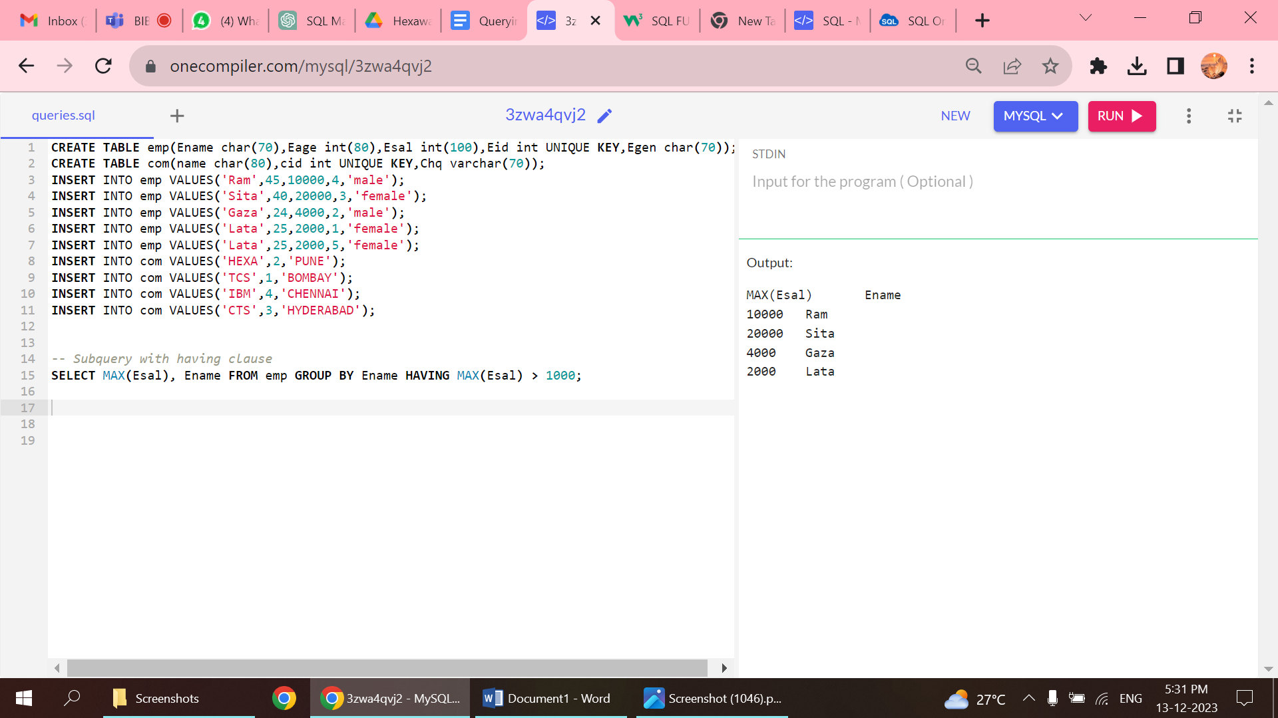

6.SUBQUERY WITH GROUP BY AND WHERE CLAUSE

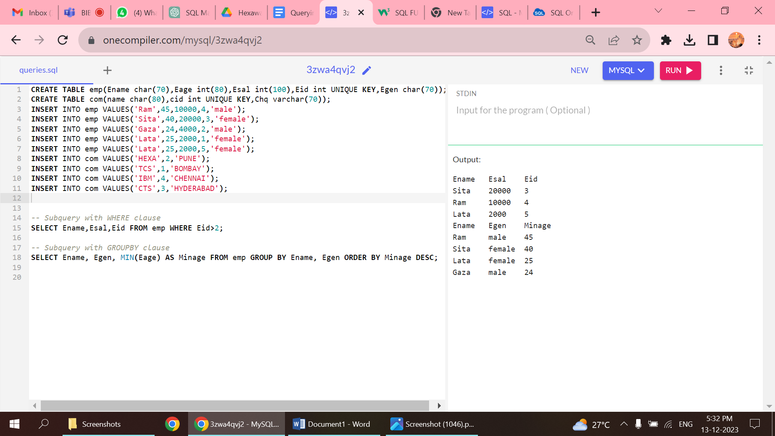

**QUESTION 2:**

Manipulate data by using sql commands using group by and having clause.

1.TABLE

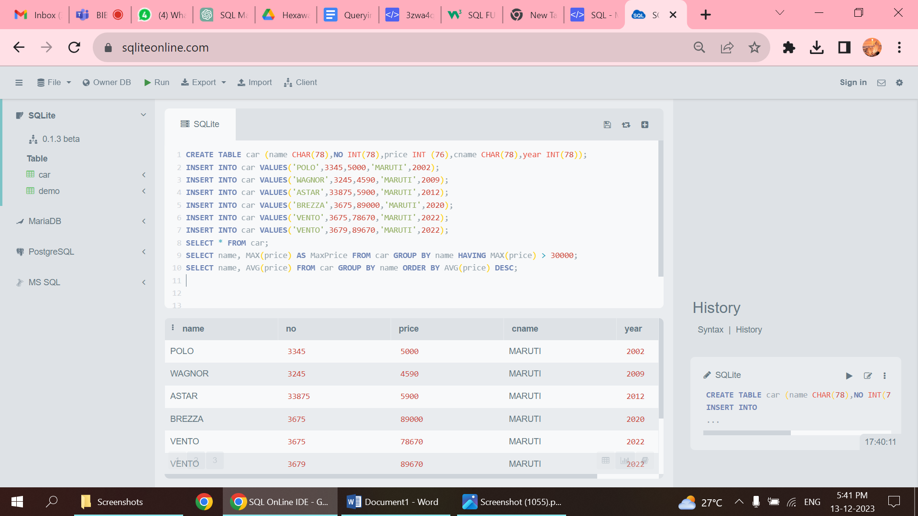

2.HAVING

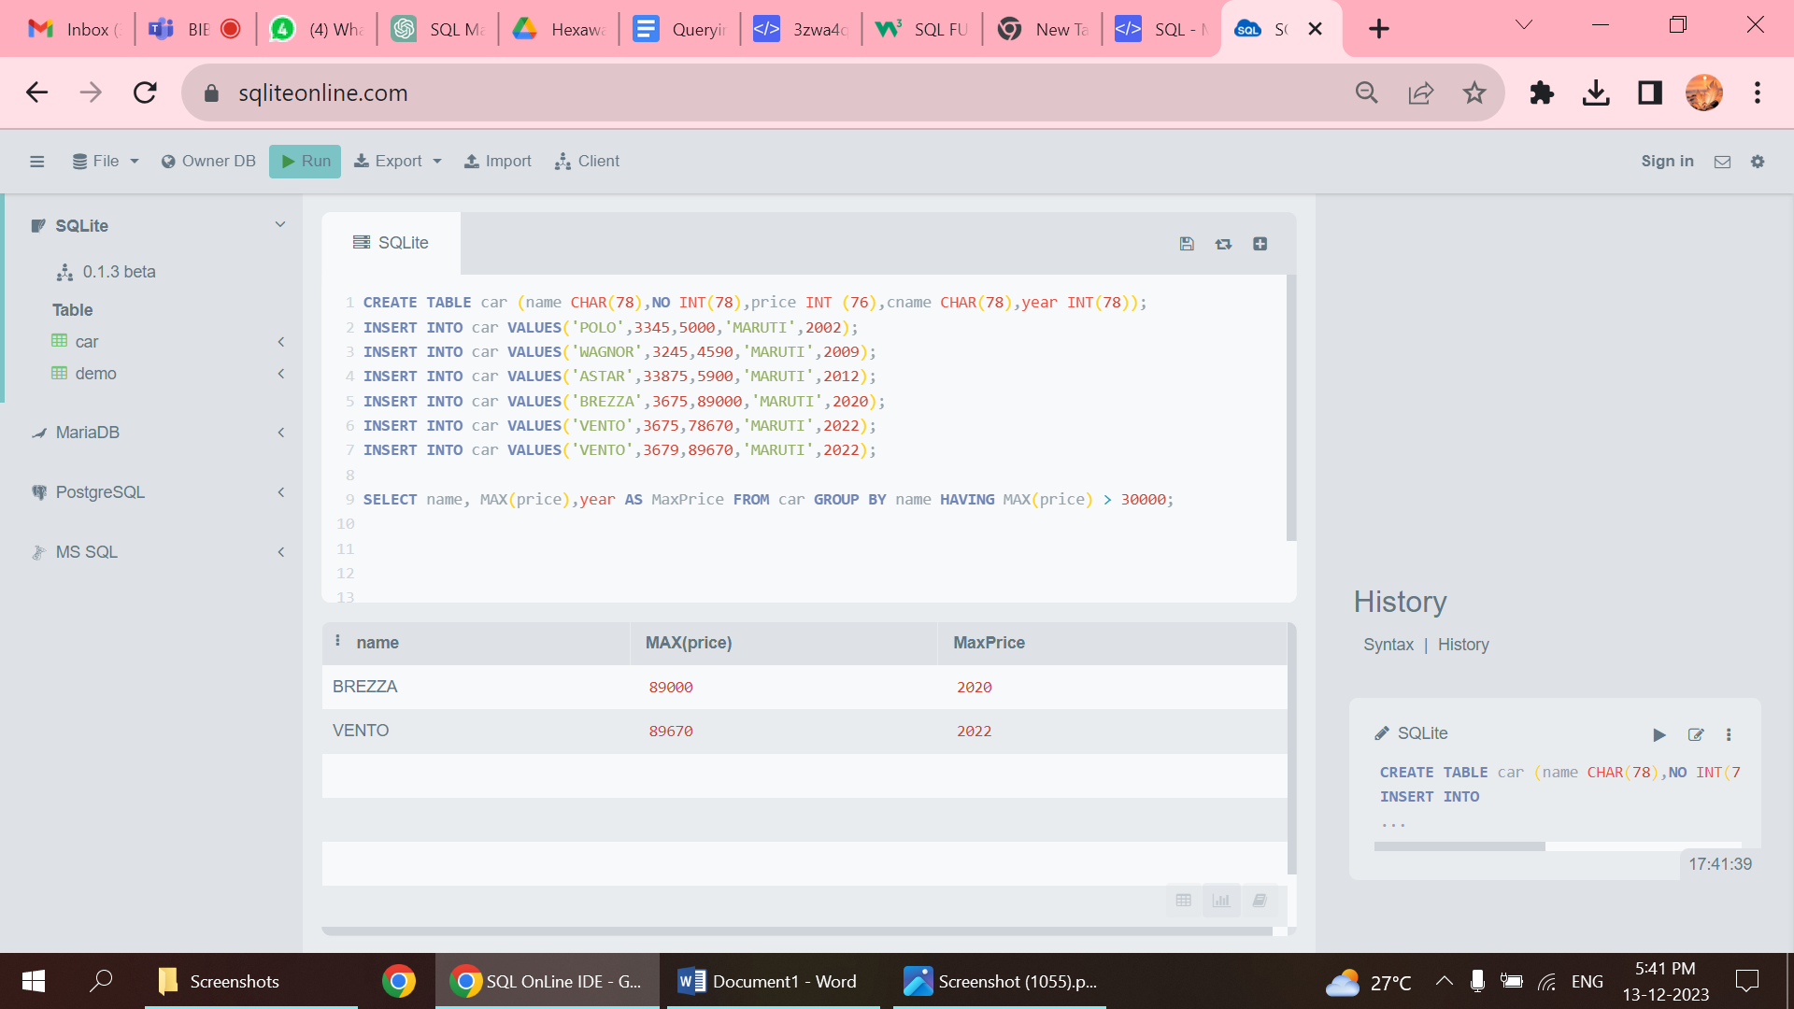

3.GROUP BY

